SQL ASSIGNMENT

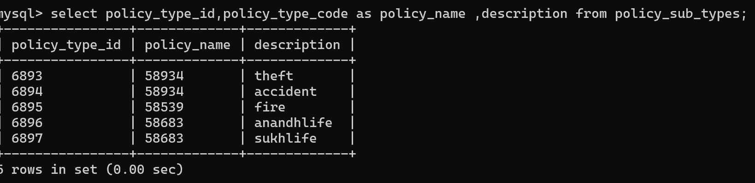

NO COLUMN NAME CALLED POLICY NAME

2.
Write a query to display the policytypecode,no of polycies in each code with alias name NO_OF_POLICIES.
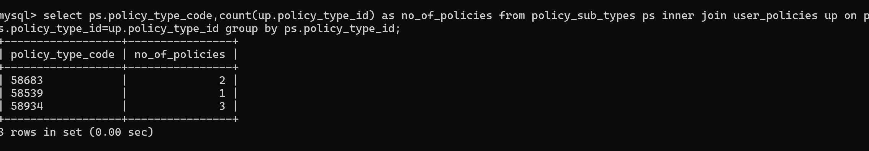

3.
Write a query to display the userid,firstname,lastname, email,mobileno who are residing in Mumbai
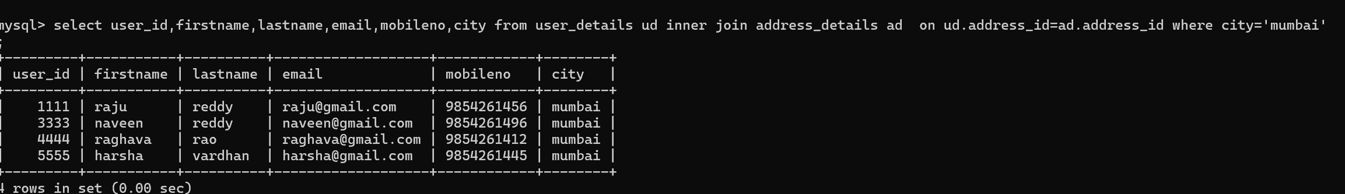

4.
Write a query to display the userid, firstname lastname with alias name USER_NAME,email,mobileno who has taken the car polycies.
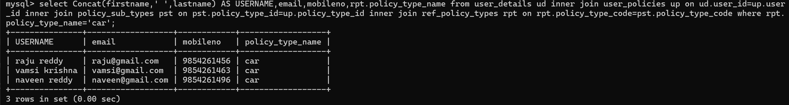
5.
Write a query to display the userid, firstname,last name who has taken the car policies but not home ploicies.
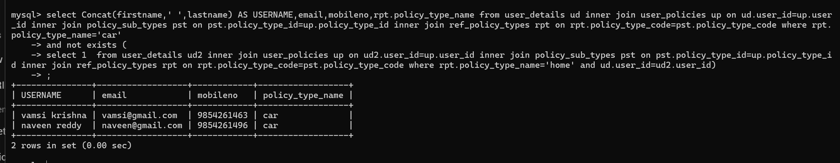

6.
Write a query to display the policytypecode, policytype name which policytype has maximum no of policies.
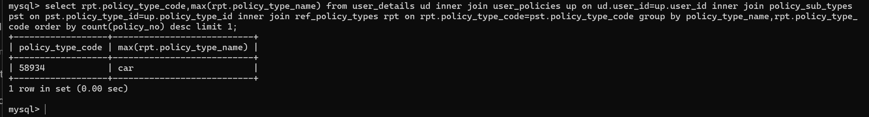

7.
Write a query to display the userid, firtsname, lastname, city state whose city is ending with ‘bad’.

8.
Write a query to display the userid, firstname, lastname ,ploicyno, dateregistered who has registered before may 2012.

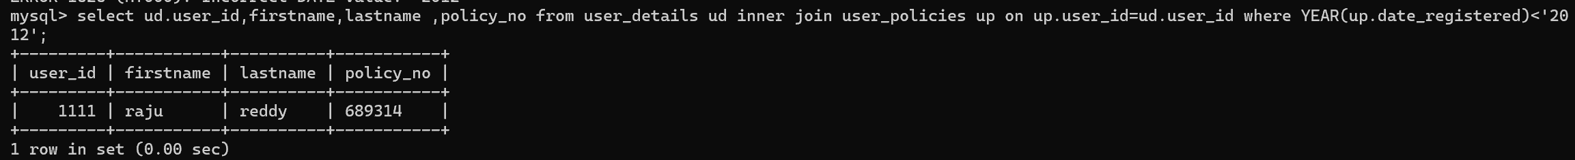

9.
Write a query to display the userid, firstname, lastname who has taken more than one policies.
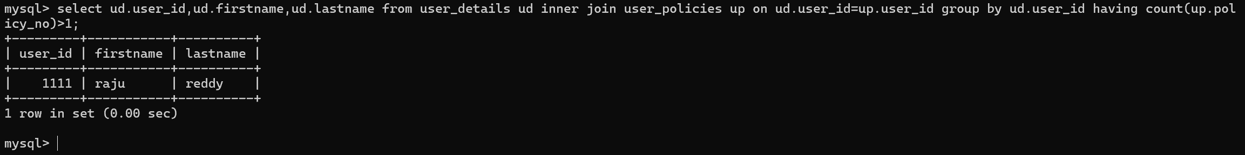
10.
Write a query to display the policytypecode, policytypename, policytypeid, userid, ploicyno whose maturity will fall in the month of august 2013.

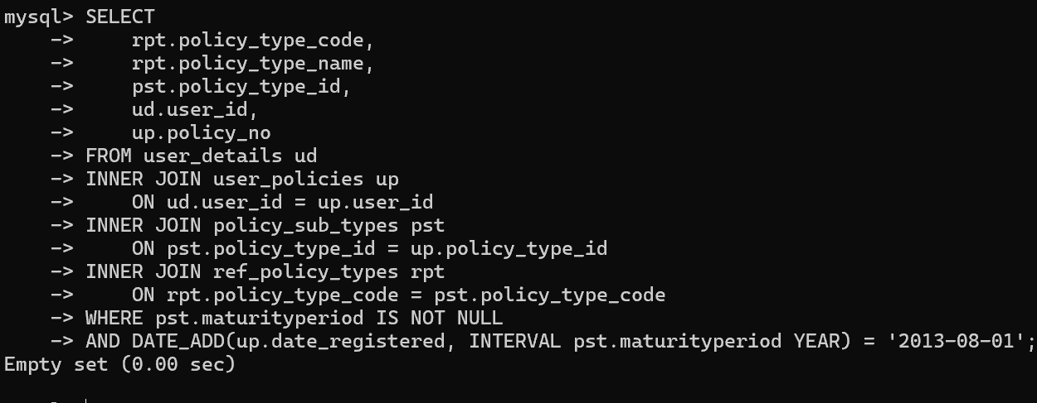

11.
Write a query to display the policytypecode, policytypename, policytypeid whose maturity amount is the double than the total paid amount.

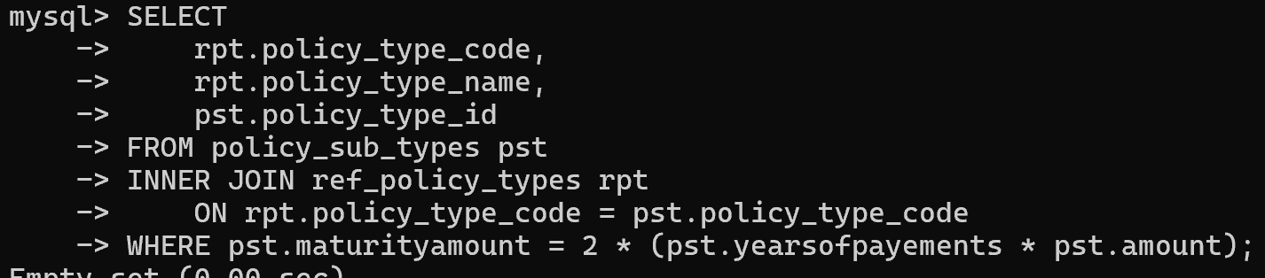

12.

Write a query to display the userid, total amount paid by the customer with alias name total_amount.
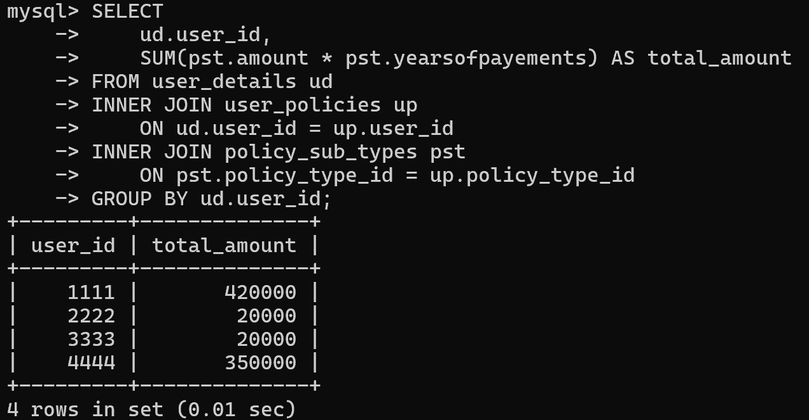

13.
Write a query to display the user_id, policy_no, total amount paid by the customer for the each
policies.

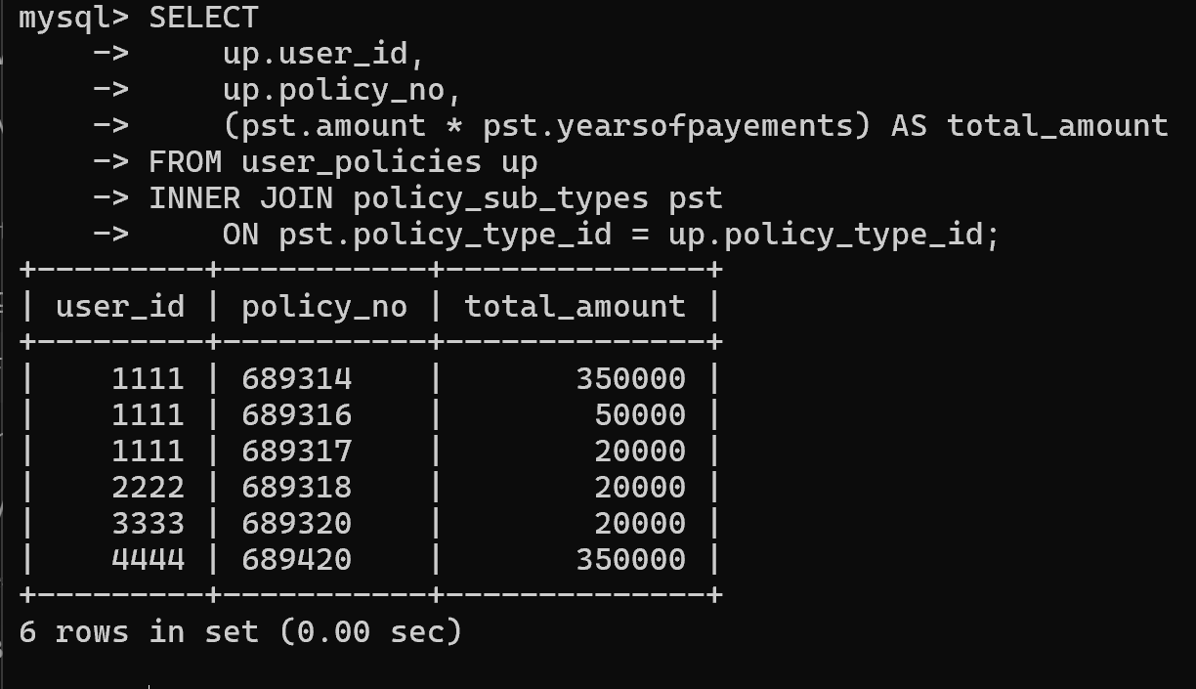
14.
Write a query to display the user_id, policy_no, balance_amount for each policies.
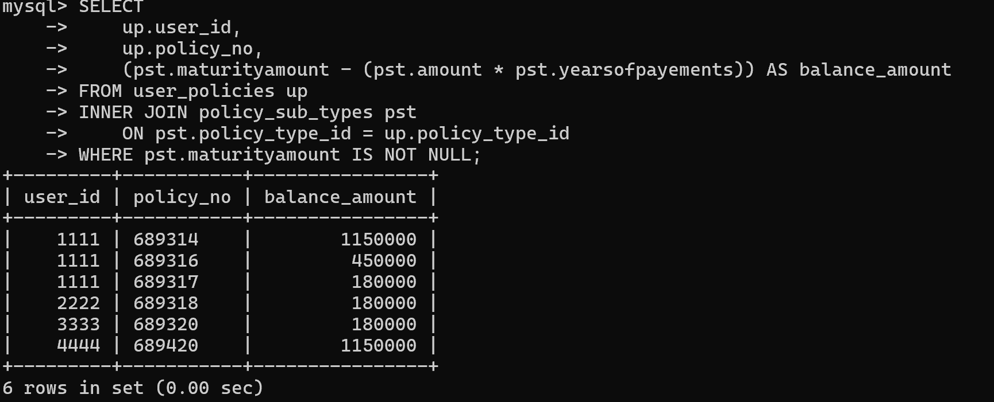

15.
write a query to display the user_id,policy_no, balancepayment years with alias name BALANCE_YEARS for all the customer for each policies.

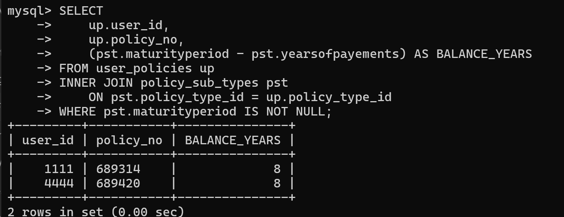

16.
Write a query to display the user details userid,firstname,last who has taken car, home and life loans.
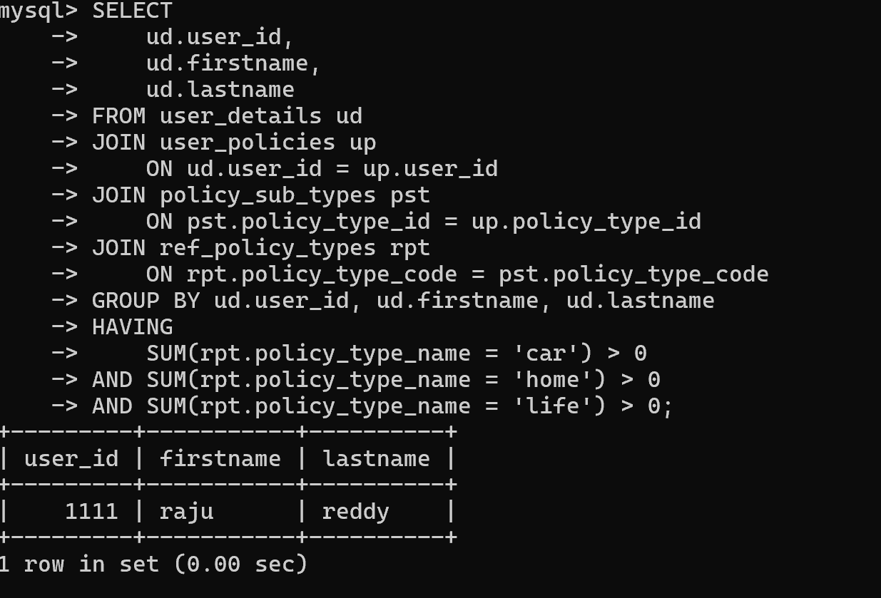

17.
Write a query to select policy_type_code,total amount paid by all the customers with alias name total_amount for each policy department.
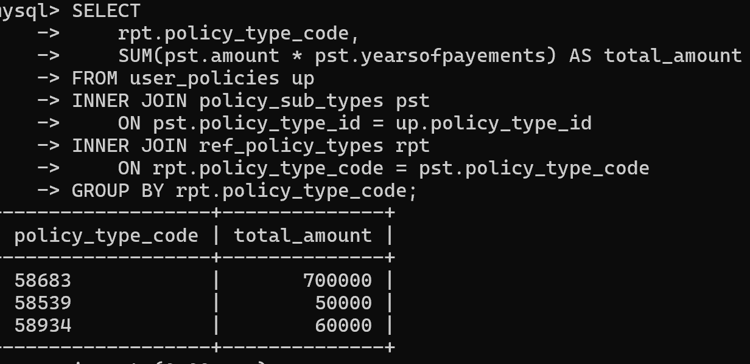
18.
Write a query to select user_id,user_name,policy_type_code,policy_type_id of users who has registered more than one policy type unde same policy code.
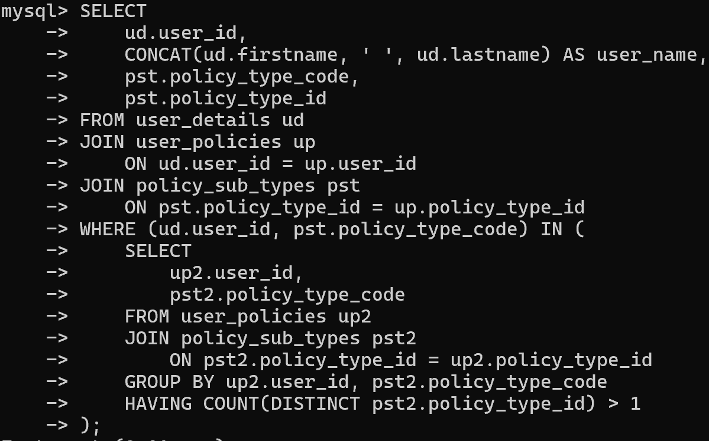

19.
Write a query to display the policy_type_code,policytype name in which policy department has min number of policies registered.
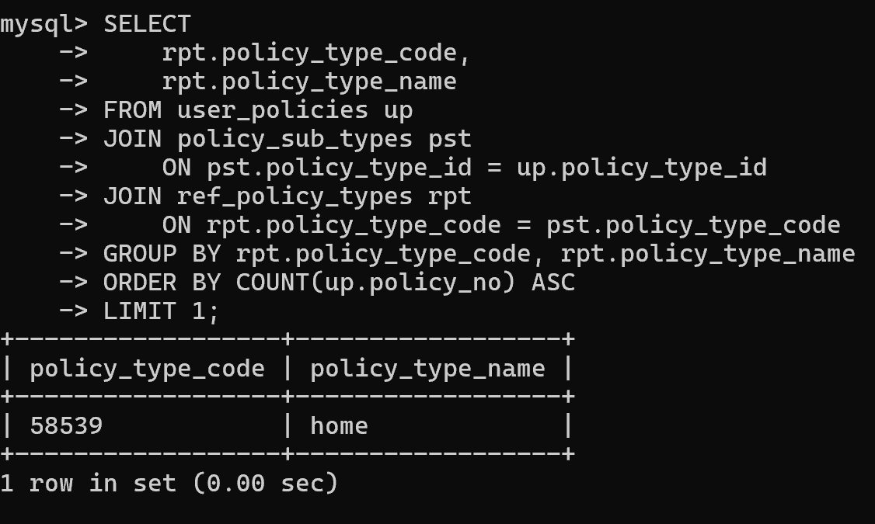

20.
Write a query to display the user_id,user_name, address,phoneno,policytypecode,policytypeid,policytypename, who has complemented all payements for the policies.
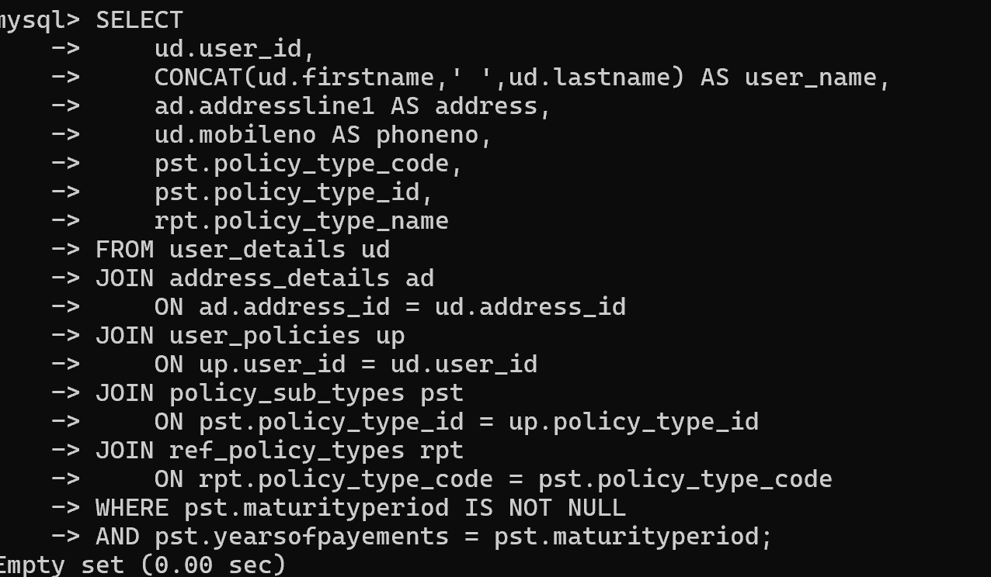

21.
write a query to display the user_id, user_name, address,phoneno,policytypecode,policytypeid,policytypename,date ofd register who has registered latest 2.
